University of Prince Edward Island Policy |  |  | Policy No. | [x] |  | Revision No. | [y]
Policy Title | Physician Faculty Appointment and Promotion Policy
Creation Date |  | [Creation Date] | Version Date |  | [Version Date]
Authority | [Authority] |  | Review Date |  | [Review Date]
Responsibility |  | [Responsibility] |  |  |  | Access

- Preamble
The University of Prince Edward Island (UPEI) recognizes the essential contributions of physician faculty in advancing the academic mission of the Faculty of Medicine (FoM). Physician faculty support the FoM through their involvement in clinical teaching, clinical education, service to their profession, the university, and the broader community, as well as research, scholarly activity, leadership, and administrative activities.
This policy applies exclusively to physician faculty appointed within the FoM. Physician faculty are licensed physicians who hold an academic appointment with the FoM and contribute to its educational, scholarly, and service missions. This policy does not apply to faculty members who are members of the UPEI Faculty Association (FA), whose appointments, promotion processes, terms and conditions of employment, and remuneration are governed by the applicable collective agreement, university policies, and employment arrangements.
Physician faculty appointed under this policy are not employees of UPEI by virtue of their academic appointment. Consistent with the Physician Services Agreement (2024-2029) and the Memorandum of Understanding Respecting the UPEI Faculty of Medicine (Appendix C), Physician faculty are remunerated by Health PEI (HPEI) for the provision of clinical education and medical teaching activities, in accordance with the terms of those agreements.
Faculty appointment and promotion are academic processes established and administered by UPEI through the Faculty of Medicine and are separate from HPEI remuneration arrangements. Academic appointments or promotions do not determine eligibility for remuneration from HPEI, and remuneration provided by HPEI does not confer, imply, or guarantee an academic appointment, academic rank, or promotion within the University.
This policy is intended to recognize and support the academic contributions of Physician Faculty while ensuring that academic appointments and promotions are conducted in a fair, transparent, and merit-based manner consistent with the mission, values, and academic standards of the Faculty of Medicine and UPEI.
- Purpose
This Policy establishes the institutional framework for the appointment, reappointment, evaluation, promotion, and termination of appointments for physician faculty within the FoM. It provides clear, consistent, and equitable processes to support faculty appointment and advancement while ensuring alignment with University policies, academic standards, values, and strategic priorities.
This policy meets the following standards of the Committee on Accreditation of Canadian Medical Schools (CACMS):
4.3: A medical school has clear policies and procedures in place for faculty member appointment, renewal of appointment, promotion, granting of tenure, remediation, and dismissal that involve a faculty member, the appropriate department head(s), and the dean, and provides each faculty member with written information about the faculty member’s term of appointment, responsibilities, lines of communication, privileges and benefits, performance evaluation and remediation, terms of dismissal, and, if relevant, the policy on practice earnings.
4.4: A medical school faculty member, consistent with the terms of the faculty member’s appointment, receives regular and timely feedback from departmental and/or other educational program or university leaders on academic performance, and, when applicable, progress toward promotion or tenure.
This policy meets the following standards of the Canadian Excellence in Residency Accreditation (CanERA):
6.1.1.1: There is an effective process for the assessment of teachers involved in residency education.
6.1.1.2: The process for the assessment of teachers includes resident input, balancing timely feedback with preserving resident confidentiality.
6.1.1.3: The process for the assessment of teachers informs teacher recognition, continuous improvement of residency programs, and the assignment of residents to teachers.
- Scope
This Policy applies to all physician faculty appointed to the Faculty of Medicine. It governs appointments, reappointments, evaluation, promotion, and related academic processes for physicians who contribute to the FoM's academic mission through clinical service; clinical teaching; service to the specialty, university, and community; research and scholarly activity; and leadership and administration. These contributions may occur in hospital, community, academic, or other affiliated clinical practice settings.
- Definitions
Term | Definition
Appointment | The formal appointment of a physician to an academic rank within the Faculty of Medicine.
Appointments Advisory Committee (AAC) | A standing committee of the Faculty of Medicine that reviews faculty applications for appointment and promotion and provides recommendations to the Dean in accordance with Faculty policies, standards, equity principles, and strategic priorities.
Associate Dean, Faculty Affairs | The senior faculty member responsible for oversight of physician faculty appointments, reappointments, evaluations, promotions, academic career development, professional development, recognition, wellness, and related faculty affairs processes.
Board of Governors | The governing body of the University of Prince Edward Island that is responsible for overseeing the University's business, financial affairs, property, and administrative operations.
Continuing Appointment | An academic appointment with no specified end date that continues until resignation, retirement, or termination in accordance with University policy.
Contributions | The creation, dissemination, application, and leadership of scholarly work that advances knowledge, improves health and medical education, informs practice or policy, and supports the mission and values of the medical school through impactful research, innovation, and community-engaged scholarship.
Cross Appointment | An academic appointment of a faculty member in a Department other than their primary academic Department within the Faculty of Medicine.
Dean | The Dean of the Faculty of Medicine.
Department | An academic unit within the Faculty of Medicine established to support education, scholarship, research, and academic leadership. Where appropriate, academic Departments may align with the corresponding Health PEI clinical department structure.
Faculty | A physician who holds an academic appointment within the Faculty of Medicine and contributes to its academic mission through teaching, scholarship, research, leadership, administration, and/or clinical education.
Faculty Appeals Committee (FAC) | An ad hoc committee established by the Dean or the Dean's delegate to hear appeals under this Policy.
Faculty of Medicine (FoM) | An academic division within a university responsible for medical education, scientific research, and clinical healthcare training.
Limited-Term Appointment | An academic appointment with a specified end date that may be eligible for reappointment in accordance with this Policy.
Physician | A professional who holds a Doctor of Medicine (MD) or equivalent degree and is licensed to practice medicine in Prince Edward Island by the College of Physicians and Surgeons of PEI (CPSPEI).
Promotion | Advancement of a faculty member from one academic rank to a higher rank based on the criteria outlined in this Policy.
Provincial Department Head | The academic leader of a Department within the Faculty of Medicine who, where applicable, also serves as the corresponding clinical department leader within Health PEI and is responsible for the academic oversight of physician faculty.
Reappointment | The renewal of a Limited-Term Appointment.
Temporary Appointment | A time-limited academic appointment used to meet short-term academic, educational, clinical, or operational needs within the FoM.
Vice President Academic and Research (VPAR) | The senior University administrator responsible for academic affairs and research, who provides institutional oversight and support to academic units and serves as the University's approving authority for matters delegated under this Policy.

- Policy

  - Guiding Principles

The following principles shall guide faculty appointments, reappointments, renewals and promotions at the FoM.

    - Academic Excellence

Appointment and promotion decisions shall recognize excellence; clinical service; clinical teaching; service to the specialty, university, and community; research and scholarly activity; and leadership and administration that advance the academic mission of the FoM. Excellence shall be evaluated in accordance with the responsibilities and scope of the faculty member's appointment.

    - Fairness and Transparency

Faculty appointment and promotion processes shall be conducted using clear criteria, consistent procedures, and documented decision-making processes. Faculty members shall have access to information regarding expectations, evaluation standards, and review procedures relevant to their appointment and career progression.

    - Equity, Diversity, and Inclusion

The FoM is committed to ensuring that appointment, evaluation, and promotion processes are equitable and free from discrimination. Review processes shall recognize the impact of career interruptions, leaves, caregiving responsibilities, disability, community engagement, and systemic barriers, and shall value diverse contributions that advance health equity, social accountability, Indigenous health, and inclusive excellence.

    - Recognition of Diverse Academic Contributions

The FoM recognizes that academic achievement may be demonstrated through a broad range of activities, including clinical service; clinical teaching; service to the specialty, university, and community; research and scholarly activity; and leadership and administration. Contributions shall be considered in a manner appropriate to the faculty member's role and responsibilities.

    - Accountability and Academic Integrity

Faculty members and decision-makers share responsibility for maintaining the highest standards of professionalism, ethical conduct, academic integrity, and stewardship. Appointment and promotion decisions shall be based on accurate, verifiable, and appropriately documented evidence of achievement and contribution.

    - Alignment with the Mission and Strategic Priorities of the FoM

Appointments and promotions should support the academic mission, strategic priorities, and social accountability commitments of the FoM and UPEI. Consideration may be given to contributions that strengthen medical education, research, patient care, faculty development, community engagement, Indigenous health, health equity, physician leadership, and the healthcare needs of Prince Edward Island and the populations served by the FoM.

  - Appointment Eligibility Requirements

All faculty appointments must satisfy the following University requirements, applicable regulatory requirements, and, where applicable, the Health PEI Physician Services Agreement:

    - Licensure and Registration:

      - Hold registration and be a member in good standing with the College of Physicians and Surgeons of Prince Edward Island (CPSPEI); and

      - Individuals holding a restricted license or registration (e.g., academic registration) may be appointed, subject to approval by the Dean.

- Clinical Affiliation: Faculty members must abide by any clinical affiliation requirements outlined by the Prince Edward Island (PEI) Physician Services Agreement in force at the time of their appointment.

    - Malpractice Coverage: Faculty members engaged in clinical practice must maintain adequate professional liability protection appropriate to their scope of practice. This typically includes membership in the Canadian Medical Protective Association (CMPA) or equivalent coverage acceptable to the FoM.

    - Compliance: Faculty must comply with applicable University, Senate, Board of Governors, and FoM policies, procedures, and regulations.

    - Failure to maintain these requirements may result in suspension, non-renewal, or termination of the appointment in accordance with this Policy and applicable University policies.

  - Appointment Categories

    - Continuing Appointment: A Continuing Appointment is an academic appointment without a specified end date and continues until resignation, retirement, or termination in accordance with University policy. Faculty members holding a Continuing Appointment are expected to maintain ongoing contributions to the academic mission of the FoM.

      - Faculty members with continuing appointments will be evaluated at regular intervals as per the process outlined in Section 5.8.

      - Should continuing appointees be found to not meet the criteria of their appointment, they may be subject to discipline as per Section 5.10.

    - Limited-Term Appointment: A Limited-Term Appointment is a formal academic appointment for a defined period of time, typically several years, where the faculty member is expected to make ongoing contributions to the FoM's academic mission through clinical service; clinical teaching; service to the specialty, university, and community; research and scholarly activity; and leadership and administration. Limited-Term faculty are generally eligible for reappointment and promotion.

      - Limited-Term appointments may be renewable.

      - Faculty are expected to maintain sustained academic contributions over the course of their term.

      - Limited-Term appointees are subject to regular evaluation and reappointment review.

    - Temporary Appointment: Temporary Appointments may be used to meet short-term academic, educational, clinical, or operational needs within the FoM. Unless otherwise specified, Temporary Appointments are time-limited and do not create an expectation of renewal, continuing appointment, or promotion.

      - Temporary Appointments may be used for:

        - Specific teaching assignments,

        - Limited-duration clinical contributions,

        - Short-term project-based academic roles

        - Filling urgent, interim, or time-limited instructional, academic, or clinical service needs.

      - Unless otherwise specified in the appointment letter or authorized by the Dean, Temporary Appointees are not eligible to receive all faculty resources and will not be considered for governance roles or committee appointments.

      - All Temporary Appointments shall be identified as such in the appointment letter, which shall specify the appointment rank (where applicable), duties, reporting relationship, start date, and end date

    - Cross Appointment: A Cross Appointment permits a faculty member to hold an academic appointment in a second Department within the FoM in addition to their primary academic appointment. Cross Appointments support interdisciplinary teaching, clinical education, scholarly activity, research, leadership, and service while maintaining clear academic reporting relationships.

      - Scope and Eligibility

        - Cross Appointments are available to faculty members who hold a primary appointment within one Department of the Faculty of Medicine and who make substantive academic contributions to a second Department through clinical service; clinical teaching; service to the specialty, university, and community; research and scholarly activity; and leadership and administration.

        - Cross Appointments are limited to Departments within the FoM and do not extend to other faculties or units of the University under this Policy.

      - Terms and Conditions

        - A Cross Appointment does not replace or diminish the responsibilities or reporting relationship associated with the faculty member's primary appointment.

        - Cross Appointment applications shall be recommended by the Provincial Department Head of the secondary Department, recommended by the Appointments Advisory Committee (AAC), and approved by the Dean. The appointment rank in the secondary Department shall normally be the same as the rank held in the primary Department.

      - Reassignment of Primary Appointment
Where a faculty member's primary academic responsibilities shift substantially to a secondary Department, they may request reassignment of their primary academic appointment. Such a reassignment requires:

        - Approval of the Provincial Department Head;

        - Recommendation from the AAC;

        - Approval from the Dean.

  - Academic Ranks
Faculty members may be appointed to one of the following academic ranks, which reflect their academic rank at other institutions, qualifications, and expected contributions to the FoM.

    - Appointment to Assistant Professor
In addition to the appointment requirements outlined under 5.2, appointments to the rank of Assistant Professor shall ordinarily require the following minimum qualifications:
      - An earned MD (or equivalent) and credential (CCFP, FRCPC, FRCSC, or equivalent) in a discipline appropriate to the appointment;

      - Evidence of, or demonstrated potential for clinical service

      - Evidence of, or demonstrated potential for, excellence in clinical teaching;

      - Evidence of, or demonstrated potential for service to the specialty, university, and community.

      - Evidence of, or demonstrated potential for, research and scholarly;

      - Evidence of, or demonstrated potential for, leadership and administration.

    - Appointment to Associate Professor
In addition to the appointment requirements outlined under 5.2, appointments to the rank of Associate Professor shall ordinarily require the following qualifications:

      - An earned MD (or equivalent) and credential (CCFP, FRCPC, FRCSC, or equivalent) in a discipline appropriate to the appointment;

      - Appointment at the level of Associate Professor at another recognized medical school.

    - Appointment to Full Professor
In addition to the appointment requirements outlined under 5.2, appointments to the rank of Full Professor shall ordinarily require the following qualifications:

      - An earned MD (or equivalent) and credential (CCFP, FRCPC, FRCSC, or equivalent) in a discipline appropriate to the appointment;

      - Appointment at the level of Full Professor or higher at another recognized medical school.

  - Promotion Principles and Criteria

    - Principles of Promotion
Promotion is an academic recognition of achievement and contribution within the Faculty of Medicine. Promotion does not confer employment with UPEI, nor does it alter a Physician Faculty member's remuneration for teaching, which is governed separately by Health PEI and the applicable Physician Services Agreement. Physician Faculty who are also employed in leadership roles by the Faculty of Medicine shall be remunerated according to their respective employment contracts.

Faculty members may be considered for promotion based on demonstrated excellence, impact, and sustained contributions in all core and one (1) (for Associate Professor) or both (for Full Professor) of the specialized pillars described in greater detail in Appendix A:

      - Core Pillars

        - Clinical Service

        - Clinical Teaching

        - Service to the specialty, university, and community

      - Specialized Pillars

        - Leadership and Administration

        - Research and Scholarly Activity

    - Promotion is not automatic and shall be based on demonstrated merit and achievement. Faculty members may apply for promotion when they believe they satisfy the criteria for the next academic rank. Faculty members may remain at their current academic rank provided they continue to meet the expectations associated with that rank.

    - Promotion to:

      - Associate Professor: Candidates shall demonstrate sustained and substantive contributions in all core and at least one specialized pillar. Evidence of growing responsibility, peer recognition, and impact is required. Their accomplishments must demonstrate substantive local or regional contributions.

      - Full Professor: Candidates shall demonstrate sustained and substantive contributions in all core and both specialized pillars. Their accomplishments must demonstrate substantive regional, national, or international contributions.
    - Leave and Career Interruptions

In evaluating applications for promotion, the FoM shall give appropriate consideration to:

      - Approved leaves under the PEI Human Rights Act or University policy, or other grounds including pregnancy, parental, medical, disability-related, or compassionate leave;

      - Other career interruptions or personal circumstances that may reasonably affect academic productivity or progression.

      - Candidates shall not be disadvantaged by approved leaves or career interruptions. Evaluation processes shall take these circumstances into account to ensure equitable assessment.

    - Inter-Institutional Promotions

Faculty members who hold concurrent academic appointments at another recognized post-secondary institution and receive an academic promotion at that institution may request consideration for an equivalent promotion at UPEI, subject to the following conditions:

      - The external promotion must have been granted through a formal academic process at a recognized post-secondary institution;

      - A request for promotion must be submitted to the AAC within one year of the external promotion;

      - The candidate must submit the documentation used to support the external promotion together with any additional information requested by the FoM.

      - Final decisions shall follow the standard promotion approval pathway established under Section 5.6

  - Appointment Process

All faculty appointments shall follow a standardized review and approval process that promotes equity, consistency, transparency, procedural fairness, and academic rigour. The appointment process includes the following:

    - Initiation

An application for appointment must be initiated by the candidate. Applicants must prepare and submit an application demonstrating that they meet the guidelines for an initial appointment. Applicants seeking appointment at the rank of Associate Professor or Full Professor must also submit evidence of appointment at this rank from another recognized medical school.

    - FoM Appointments Advisory Committee (AAC)

The AAC shall review the application to ensure completeness and review it against the appointment criteria established in this Policy.

    - The Dean of the FoM
The Dean is the final FoM authority responsible for reviewing and recommending appointments, reappointments, and promotions before submission for institutional approval. The Dean may:
      - Concur with AAC recommendations;

      - Return applications to the AAC or the Provincial Department Head for clarification or additional information; or

      - Recommend an alternative appointment decision, with written rationale.

    - VPAR

The Vice-President Academic and Research (VPAR) shall review appointment recommendations in accordance with University governance processes and, where required, recommend approval to the Board of Governors.

    - Communication

Appointment decisions shall be communicated to the applicant or faculty member in writing.

  - Promotion Process

All faculty reappointments and promotions shall follow a standardized review and approval pathway that promotes equity, consistency, transparency, procedural fairness, and academic rigour. The promotion process pathway goes through the following:

    - Initiation

An application for promotion may be initiated by the candidate or recommended by the Provincial Department Head. Applicants must prepare and submit a complete application which provides evidence that they have met all requirements for promotion.

    - FoM Appointments Advisory Committee (AAC)

      - The AAC shall review the application to ensure completeness and assess it against the promotion criteria established in this Policy.

      - The AAC shall ensure consistency, academic rigour, procedural fairness, and appropriate consideration of individual circumstances, including equity-related factors.

      - Contributions arising from a Cross Appointment shall be considered during promotion processes, with input from both Departments where appropriate.

      - Following its review, the AAC shall provide a written recommendation to the Dean.

    - The Dean of the FoM
The Dean is the final FoM authority responsible for reviewing and recommending reappointments, and promotions before submission for institutional approval. The Dean may:
      - Concur with AAC recommendations;

      - Return applications to the AAC or the Provincial Department Head for clarification or additional information; or

      - Recommend an alternative promotion decision, with written rationale.

    - VPAR

The Vice-President Academic and Research (VPAR) shall review promotion recommendations in accordance with University governance processes and, where required, recommend approval to the Board of Governors.

    - Communication

Promotion decisions shall be communicated to the applicant or faculty member in writing.

5.7.6 Effective Date of Promotion

Any promotion shall take effect on July 1 following the completion of the review of approval processes.

  - Faculty Evaluation

    - Faculty Performance Evaluation

Faculty members shall receive periodic evaluation appropriate to their appointment type and academic responsibilities. Evaluations shall normally be conducted by the Provincial Department Head (or designate) and may consider teaching evaluations, scholarly activity, clinical contributions, leadership, service, and other relevant evidence appropriate to the faculty member's role. Evaluation outcomes should inform faculty development, recognition, reappointment, and promotion.

    - The evaluation process shall:

      - Be proportionate to the expectations and responsibilities associated with the faculty member's rank and appointment type;

      - Recognise the diverse ways in which faculty contribute to the academic mission of the FoM across the academic pillars described in Appendix A.

      - Be guided by the principles in Section 5.1.

  - Renewal of Appointment

Faculty members are not required to seek promotion and may remain at their current academic rank, provided they continue to satisfy the expectations associated with their appointment during the standard academic review process outlined in Section 5.8.2.

  - Discipline

    - Allegations of misconduct and faculty discipline shall be addressed in accordance with the FoM’s established disciplinary procedures.

    - Removal of Faculty Member from Learner Contact Pending Investigation

      - A faculty member may be temporarily removed from learner-facing responsibilities pending investigation in instances where serious allegations of misconduct, learner mistreatment, professionalism concerns, or other conduct that may pose a risk to learners, patients, or the learning environment arise.

        - During an internal or external investigation conducted by the University, Health PEI, an affiliated institution, or a professional regulatory body;

        - Upon the recommendation of the appropriate academic leader (e.g., Provincial Department Head, Associate Dean, Faculty Affairs, or Senior Associate Dean), with approval of the Dean.

      - This action is administrative and precautionary rather than disciplinary and shall be communicated to the faculty member in writing, together with the reasons for the decision. Learner-facing responsibilities may be reinstated following resolution of the matter and completion of any required remedial or corrective measures.

      - The FoM shall comply with the notification requirements established under the Health PEI–UPEI Affiliation Agreement (Appendix B) regarding concerns related to the conduct or qualifications of Dual Appointees.

    - Procedural Fairness
Before disciplinary action is imposed, the faculty member shall normally be provided with written notice of the concerns, an opportunity to respond, and consideration of their response, except where immediate action is necessary to protect learners, patients, or the integrity of an investigation.
    - Suspension or Termination of Appointment
A faculty member may be subject to disciplinary action, up to and including suspension or termination of their academic appointment, where one or more of the following circumstances apply:
      - Failure to Meet Appointment Requirements
The faculty member no longer satisfies the appointment requirements established under this Policy, including:

        - Loss of licensure or professional certification;

        - Suspension or termination of hospital or clinical privileges;

        - Failure to maintain adequate malpractice insurance;

        - Failure to fulfil the academic responsibilities associated with the appointment, without approved leave or other authorized absence.

      - Breach of Policy or Conduct Expectations
A breach of applicable University, FoM, or affiliated institutional policies, procedures, or professional standards has occurred, including:

        - Misconduct or unprofessional behaviour in teaching, clinical, or academic contexts;

        - Failure to comply with the FoM Professionalism Statement;

        - Findings of professional misconduct or disciplinary action by a professional regulatory body.

      - Non-Compliance with Investigative or Remedial Processes
Refusal or failure to participate in, or comply with, investigation, remediation, or disciplinary processes required by the FoM, the University, Health PEI, or another affiliated institution may result in disciplinary action. Where appropriate, progressive discipline shall be applied and may include suspension or termination of the academic appointment.
  - Appeals Process

    - Faculty members who receive an adverse decision under this Policy may submit an appeal in accordance with the procedures established by the FoM.

      - Promotion;

      - Non-renewal of appointment;

      - Termination or denial of an appointment;

    - A written appeal must be submitted to the Dean within twenty (20) business days of the date of the written decision.

    - Grounds for Appeal
An appeal under this Policy shall be based on one or more of the following grounds:

      - A material procedural error that may have affected the outcome of the decision;

      - A failure to apply this Policy or applicable University policies appropriately;

      - A demonstrated conflict of interest or reasonable apprehension of bias in the decision-making process; or

      - New information that was not reasonably available at the time of the original decision and that could reasonably be expected to have affected the outcome.

    - An appeal is not a rehearing of the original application and shall not be based solely on disagreement with the academic judgment or recommendation of the original decision-makers.

    - The Faculty Appeals Committee (FAC) shall be convened as an ad hoc committee by the Dean or the Dean's delegate within fifteen (15) days of receipt of a written appeal. The Committee shall conduct its work in accordance with the principles of:

      - Procedural fairness;

      - Effective conflict-of-interest management; and

      - Consensus-based decision-making wherever possible, with decisions determined by majority vote where consensus cannot be achieved.

    - The FAC shall make recommendations to the Dean, who shall make the final decision. The Committee does not have authority to overturn decisions reserved to the President, the Vice-President Academic and Research, or the Board of Governors under the PEI University Act.

      - The authority of the FAC is limited to the matters delegated under this Policy and applicable University governance documents.
  - Responsibilities

    - Associate Dean, Faculty Affairs

The Associate Dean, Faculty Affairs is responsible for:

      - Oversight of physician faculty appointments, reappointments, evaluations, promotions, academic career development, recognition, wellness, and related faculty affairs processes.

      - Ensuring compliance with applicable University and FoM policies.

      - Promoting equitable and inclusive faculty advancement practices.

    - Provincial Department Heads

Each academic department is led by a Provincial Department Head who, where appropriate, also serves as the corresponding clinical department lead within Health PEI. Provincial Department Heads are responsible for:

      - Providing academic leadership and administration within the Department;
      - Overseeing faculty recruitment, onboarding, retention, evaluation, mentorship, career development, faculty wellness, and promotion;
      - Ensuring departmental compliance with University and FoM policies;
      - Reviewing and recommending applications for appointment, reappointment, and promotion to the Appointments Advisory Committee (AAC); and
      - Fostering the academic mission of the FoM through teaching, scholarship, research, leadership, and service.

    - FoM Appointments Advisory Committee (AAC)

The AAC is responsible for:

      - Reviewing and assessing applications for appointment, reappointment, and promotion;
      - Promoting consistency, transparency, academic rigour, and fairness in appointment and promotion decisions;
      - Considering structural inequities, career interruptions, and other systemic factors that may influence faculty career progression;
      - Providing recommendations to the Dean regarding appointments and promotions; and
      - Conducting its work in accordance with the principles of equity, procedural fairness, confidentiality, consensus-based decision-making where possible, and appropriate conflict-of-interest management.

    - FoM Faculty Appeals Committee (FAC)
The FAC is responsible for:
      - Reviewing appeals submitted by faculty members in accordance with the timelines and procedures established by the FoM;

      - Determine whether the appointment, promotion, renewal, or disciplinary process was conducted in a fair, consistent, and procedurally appropriate manner;

      - Consider relevant information, documentation, and submissions provided by the appellant and the original decision-making bodies;

      - Ensure that actual, potential, or perceived conflicts of interest are identified and appropriately managed throughout the appeal process;

      - Conduct its deliberations in a manner that respects confidentiality, procedural fairness, and the principles of natural justice;

      - Assess whether the criteria and requirements of this policy were applied consistently and appropriately in the original decision;

      - Make recommendations to the Dean regarding the disposition of an appeal, including whether a decision should be upheld, reconsidered, or returned for further review;

      - Maintain records of appeal proceedings and recommendations in accordance with applicable University policies and record management requirements.

  - Members of committees established under this Policy shall maintain the confidentiality of committee deliberations, records, consultations, and proceedings, except where disclosure is required by law or University policy. This obligation also applies to consultants, legal counsel, academic colleagues, witnesses, parties, and other individuals participating in committee proceedings, subject to applicable legislation and University policy.

  - This Policy shall be reviewed at least every three (3) years, or earlier as required to reflect changes in legislation, University governance documents, accreditation standards, or FoM requirements.

- Equity, Diversity, and Inclusion
  - The UPEI Faculty of Medicine is committed to ensuring that faculty appointment, reappointment, evaluation, promotion, and appeal processes are conducted in a fair, transparent, equitable and inclusive manner. The FoM recognizes that academic excellence may be demonstrated through diverse contributions in teaching, clinical service, research and scholarly activity, leadership, administration, and community engagement, and that traditional measures of achievement may not fully capture the breadth of a faculty member's contributions and impact.
  - Individuals involved in appointment, evaluation, promotion, and appeal processes, including Provincial Department Heads, the Appointments Advisory Committee (AAC), and the Faculty Appeals Committee (FAC), shall recognize the potential influence of conscious and unconscious bias and apply the criteria established in this Policy consistently, fairly, and equitably. Evaluation and review processes shall recognize that career progression may be influenced by disability, caregiving responsibilities, pregnancy, parental or medical leave, cultural or ceremonial obligations, community engagement, Indigenous leadership, and other personal or professional circumstances.
  - The FoM values contributions that advance equity, diversity, inclusion, accessibility, Indigenous health, community engagement, social accountability, reconciliation and the health of underserved or structurally marginalized populations. Where appropriate to a faculty member's academic role, these contributions shall be recognized as evidence of academic achievement within the pillars of teaching and educational activities, clinical service, research and scholarly activity, and leadership and administration.
  - Appointment, evaluation, promotion, renewal, and appeal decisions shall not discriminate on the basis of any protected characteristic under applicable human rights legislation, including race, ethnicity, Indigenous identity, place of origin, citizenship, religion, age, disability, sex, sexual orientation, gender identity, gender expression, family status, or any other protected ground. The FoM is committed to fostering an inclusive academic environment in which all faculty members have equitable opportunities for appointment, advancement, recognition, leadership, participation, and professional development.

- References
- PEI Human Rights Act RSPEI 1988, c H-12
- PEI University Act RSPEI 1988, c U-4
- Health PEI–UPEI Affiliation Agreement (Appendix B)
- Committee on Accreditation of Canadian Medical Schools (CACMS) Standards
- Canadian Excellence in Residency Accreditation (CanERA) Standards
- FoM Professionalism Statement
- University of Prince Edward Island Harassment and Discrimination Policy
- 2024-2029 Physician Services Agreement: Memorandum of Understanding Respecting the UPEI Medical School (Appendix C)

- Version History
Date | Action
 | Version 1.0 approved.

Appendix A: Principles for Promotion

Pillars for Promotion
Promotion within the Faculty of Medicine (FoM) shall be based on demonstrated excellence, impact, and sustained contributions in all Core and one (for Associate Professor) or both (for Full Professor) of the Specialized pillars.
Faculty members are not expected to demonstrate equal achievement across all academic pillars. Promotion decisions shall recognize that the relative emphasis placed on teaching, clinical service, research and scholarly activity, and leadership and administration may vary according to an individual's appointment, discipline, academic role, and career stage. Excellence in one or more pillars, together with meaningful contributions across the FoM's academic mission, shall be considered in determining readiness for promotion.
The examples below are illustrative rather than exhaustive and shall be interpreted in a manner appropriate to the faculty member's academic role and appointment.
- Core Pillars

  - Clinical Service
Faculty members engaged in clinical practice are expected to maintain exemplary standards of patient care appropriate to their professional licensure, scope of practice, and academic responsibilities. Excellence in clinical service is demonstrated through:

- Clinical activities aligned with the ethical, professional, and regulatory expectations of relevant licensing bodies and affiliated institutions;
- Evidence of clinical competence and professionalism;
- Recognition of clinical service by peers, patients, and/or institutions;
- Service in clinical leadership roles or administrative functions related to care delivery.

  - Clinical Teaching
Teaching contributions include the instruction, supervision, and mentorship of learners across clinical, classroom, and community-based settings. Teaching may occur within undergraduate, postgraduate, graduate, or continuing professional education environments and should demonstrate excellence in educational practice, learner engagement, curriculum development, educational innovation, and inclusive teaching. Assessment of teaching effectiveness may include:

- Learner evaluations of teaching (quantitative and qualitative);
- Peer assessments of teaching;
- Teaching awards;
- Contributions to learner supervision, clinical teaching, or competency-based assessment in the clinical environment;
- Contributions to faculty development or mentorship;
- Educational leadership at the local, provincial, national, or international level; and
- Integration of Equity, Diversity, and Inclusion (EDI) principles in teaching and assessment.
The FoM recognizes that teaching which meaningfully incorporates Indigenous knowledge, culturally responsive educational practices, accessibility, or educational outreach to underserved communities is integral to its academic mission.
  - Service to the specialty, university, and community
Service and community engagement is valued within and beyond UPEI and the FoM where it advances the FoM’s mission, including equity, diversity, inclusion, accessibility, Indigenous health, social accountability, and service to the communities of Prince Edward Island.
Assessment of service to the specialty, university, and community could include, but would not be limited to:
- Participation in quality improvement or person-centered safety initiatives;
- Participation in institutional, hospital, regional, or national committees;
- Advocacy and service related to health equity, Indigenous engagement, or underserved communities;
- Volunteer service supporting charitable, community, cultural, or health-related organizations;
- Leadership or participation in community-based health initiatives, health promotion programs, or community advisory boards;
- Public health advocacy, media and public education, patient advisory groups;
- Service to municipal, provincial, or federal government or nongovernment organizations.

- Specialized Pillars

  - Leadership and Administration

Leadership contributions include engagement in academic, administrative, governance, or strategic roles that advance the missions of the FoM, the University, the healthcare system, or the communities it serves. Leadership and administrative activities can occur in the academic or clinical learning environment. Recognized activities include:

Academic Leadership and Administration

- Service in academic leadership roles (e.g., decanal role, program director);
- Evidence of curriculum development or instructional innovation;
- Leadership of educational or policy development initiatives;
- Leadership in academic accreditation, quality improvement, faculty development, or learner wellness initiatives;
- Mentorship of peers or junior faculty.

Clinical Leadership and Administration
- Service in clinical leadership roles (e.g., department head);
- Leadership of clinical policy development initiatives;
- Leadership roles within professional societies, specialty organizations, certification bodies, or licensing organizations;
- Development and implementation of innovative care models and practice guidelines;
- Leadership in clinical accreditation, quality assurance, or quality improvement initiatives;
- Mentorship of peers or junior faculty.

  - Research and Scholarly Activity

Research and scholarly contributions may encompass a broad range of academic outputs, including but not limited to:
- Peer-reviewed publications, clinical guidelines, or scholarly books;
- Abstracts and presentations at academic or professional conferences;
- Participation on research ethics boards and research committees;
- Educational scholarship or innovations;
- Leadership in research collaborations or clinical trials;
- Creative and community-based scholarship (e.g., narrative medicine, graphic medicine, health policy writing, Indigenous methodologies);
- Grant funding, program evaluation, or implementation science;
- Public scholarship through media, digital platforms, or health advocacy.

Evaluation of scholarly activity shall prioritize quality, substance, innovation, and impact over publication volume or journal metrics. Peer-reviewed or community-endorsed outputs, especially those addressing health equity, primary care, generalism, or the needs of structurally marginalized populations, shall be highly valued.

Appendix B: Fully Executed Health PEI - UPEI Affiliation Agreement (2026-2036)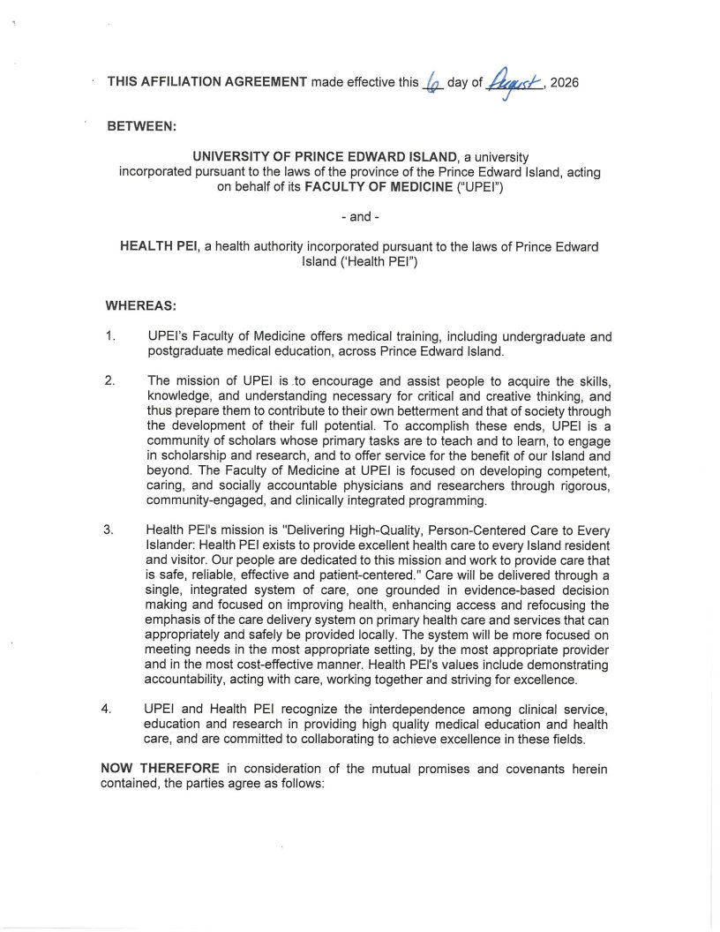
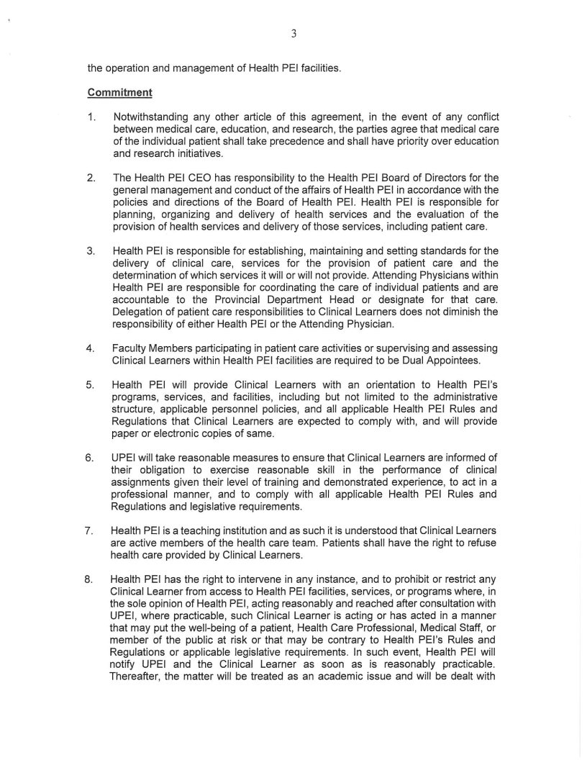
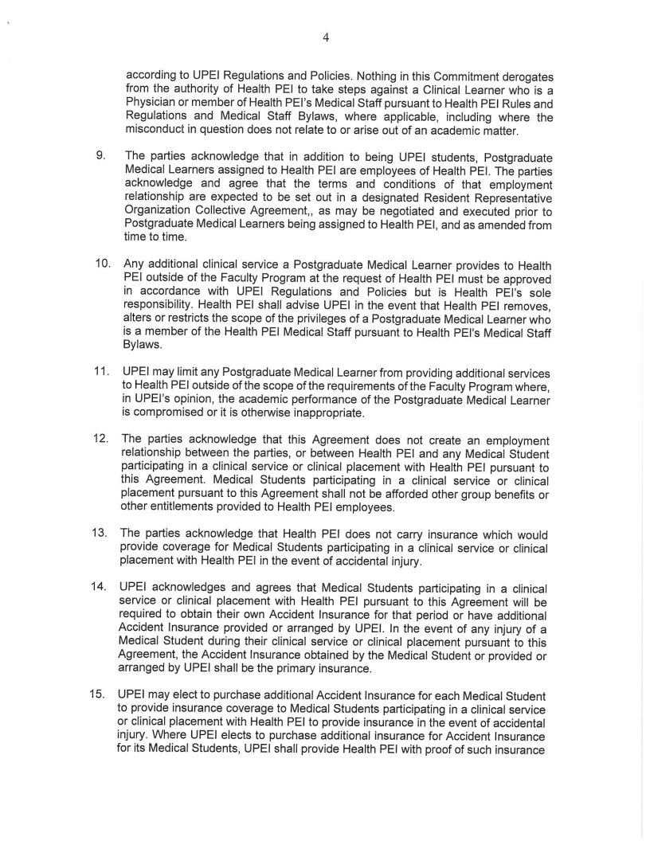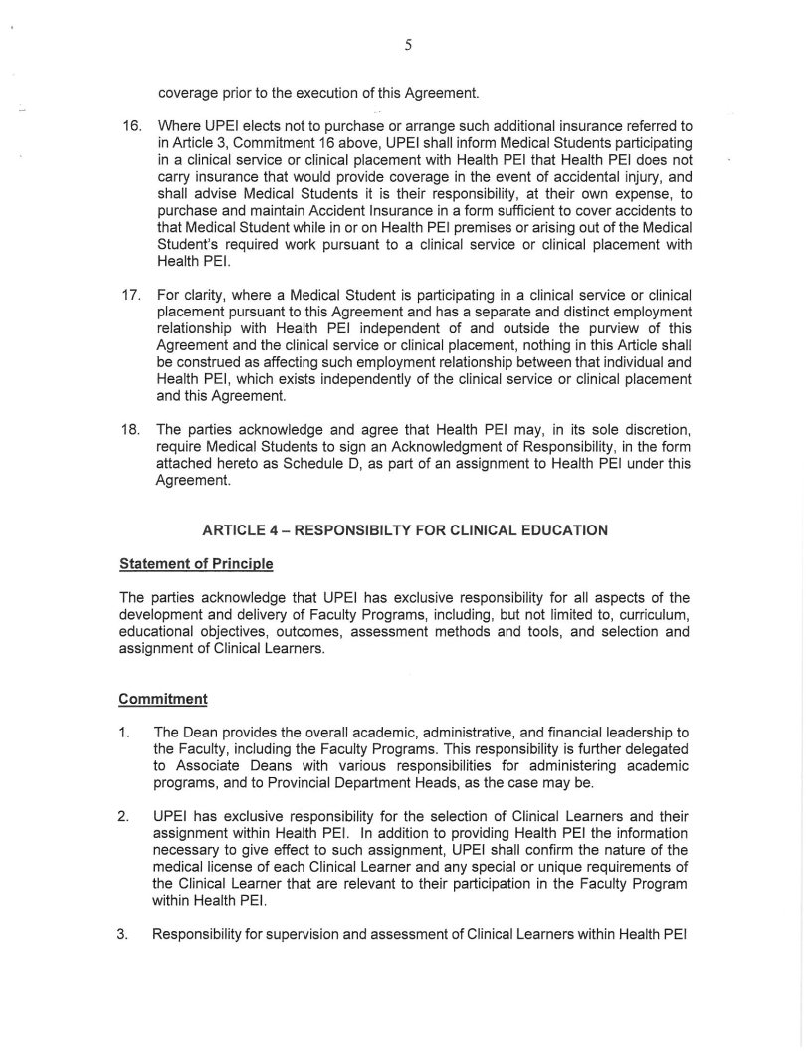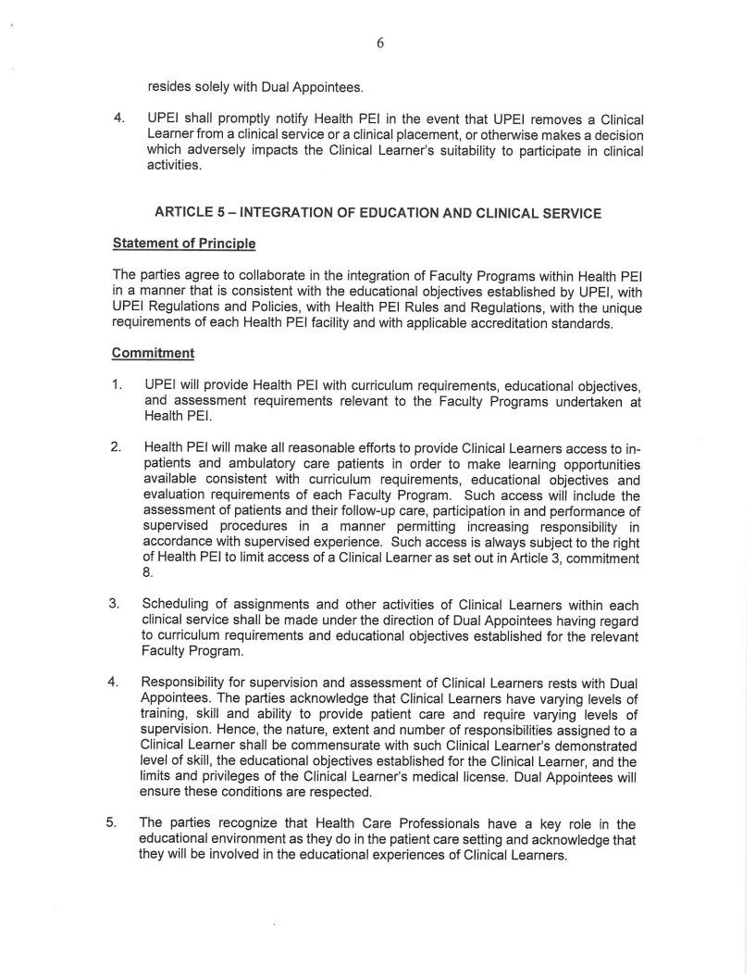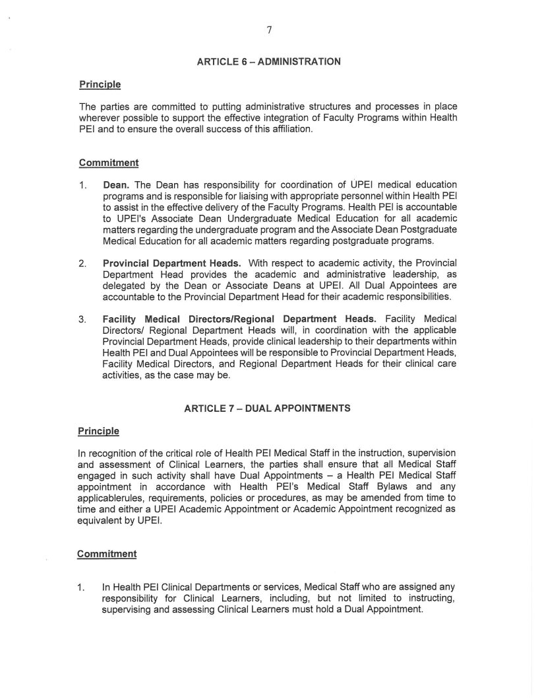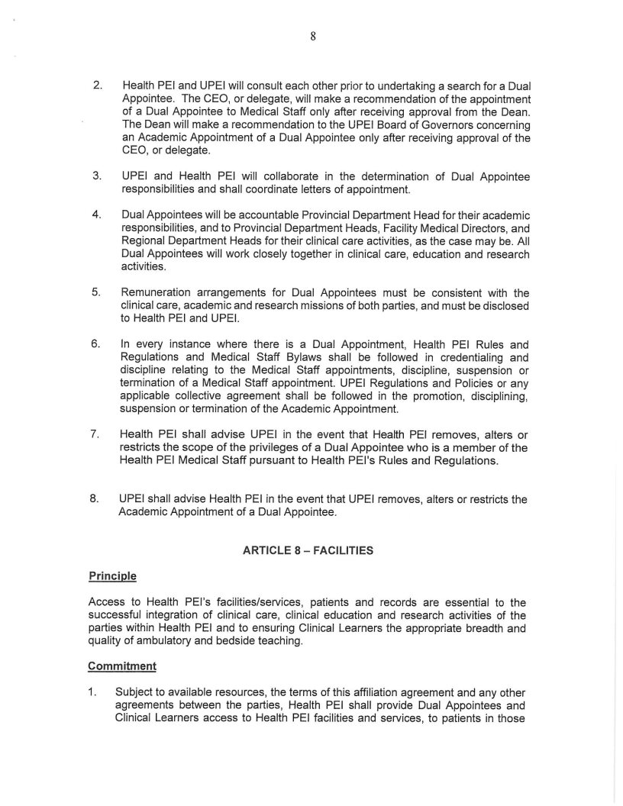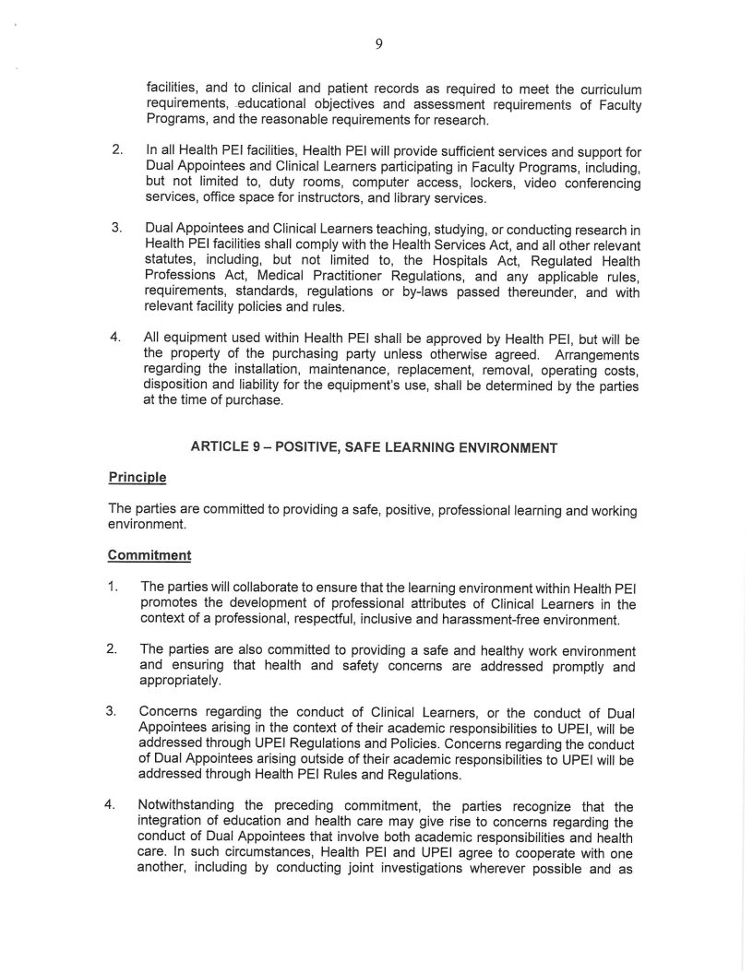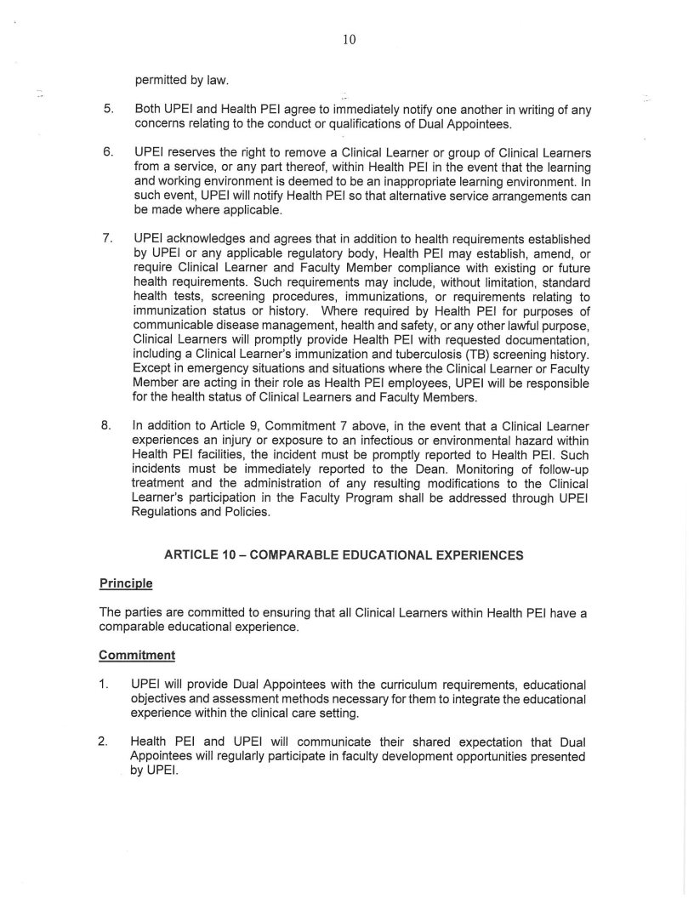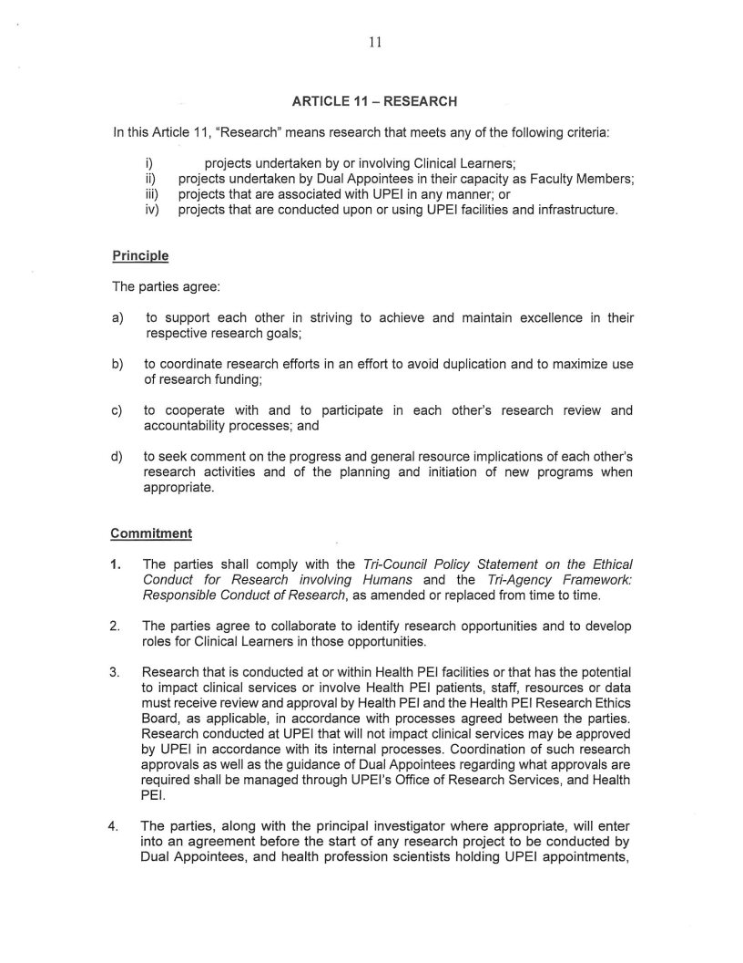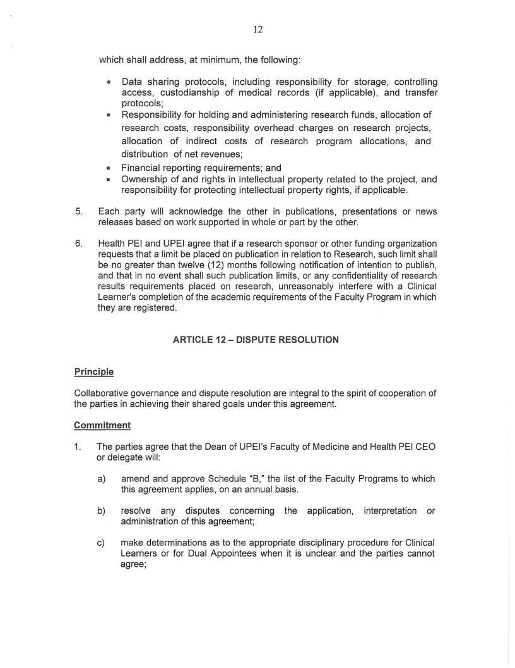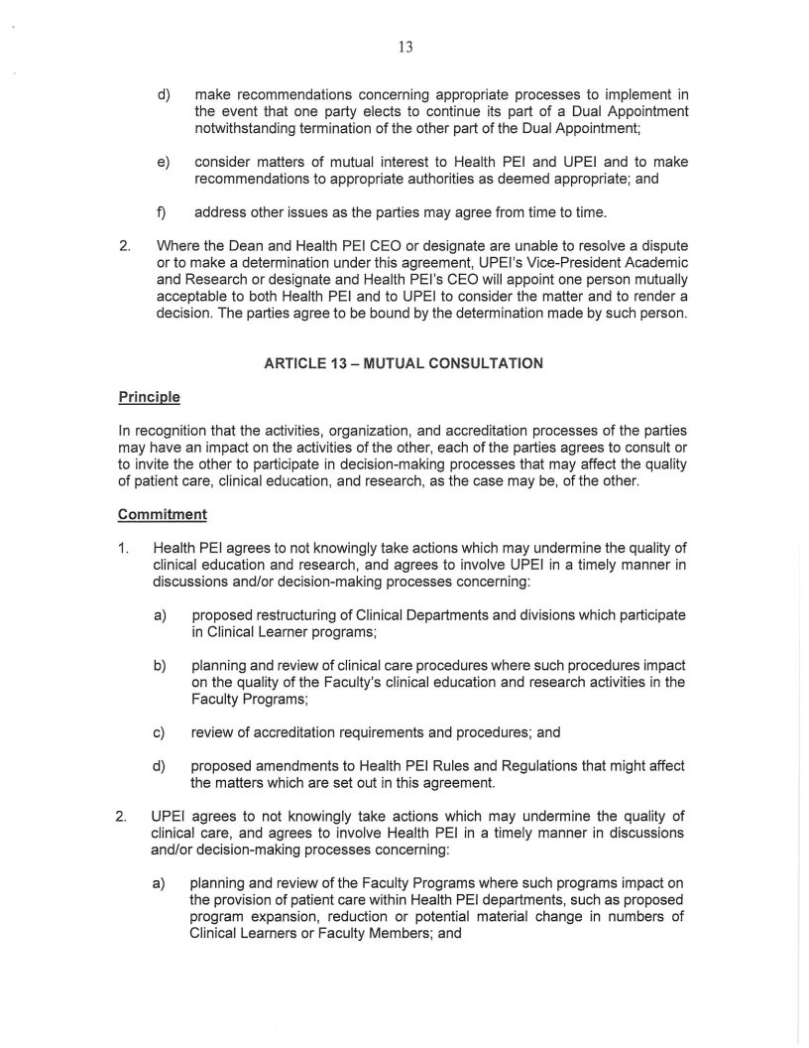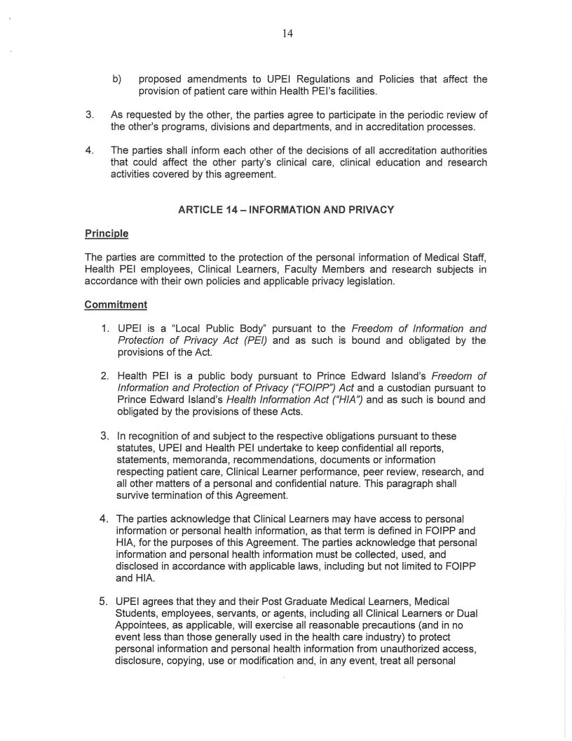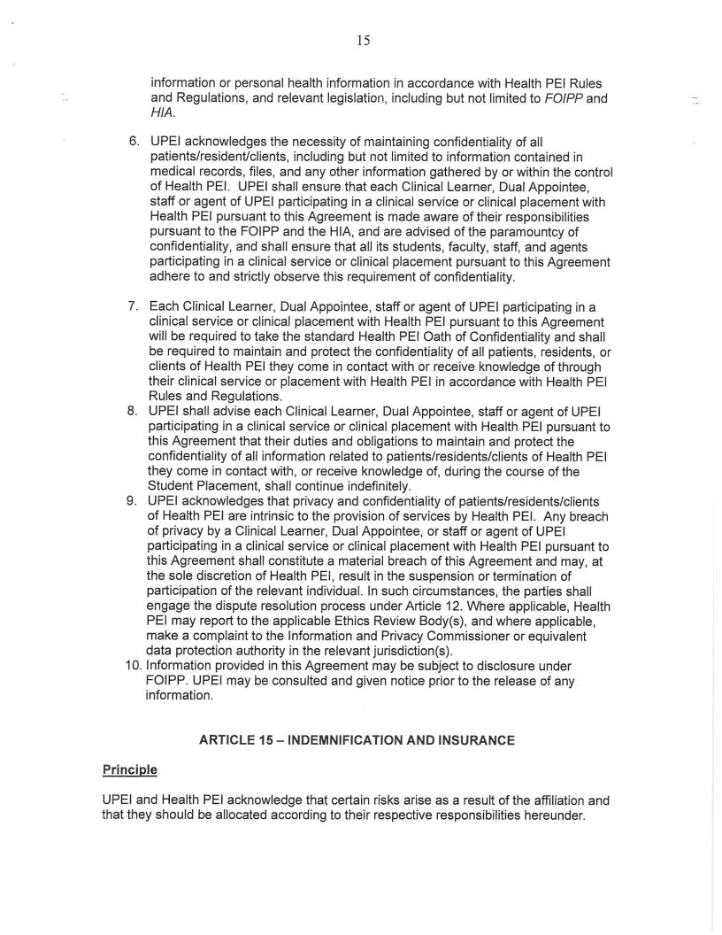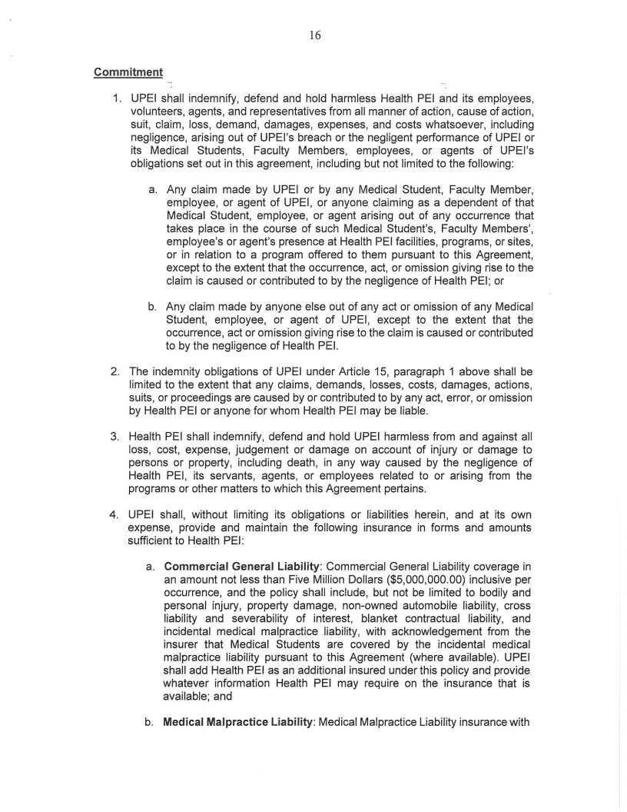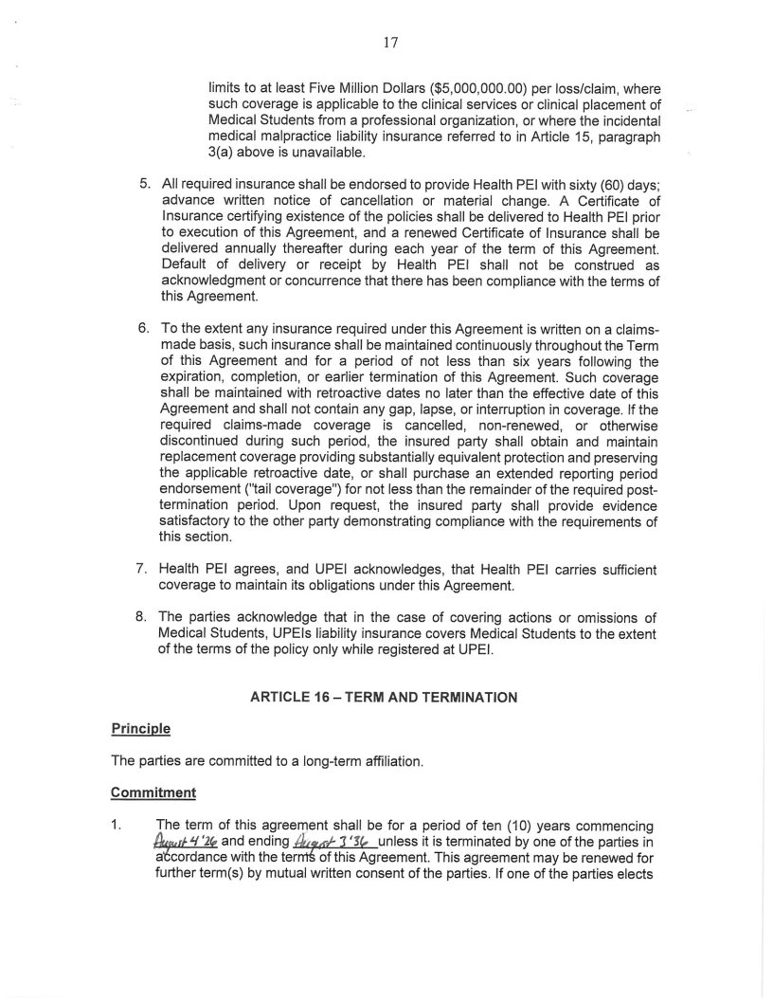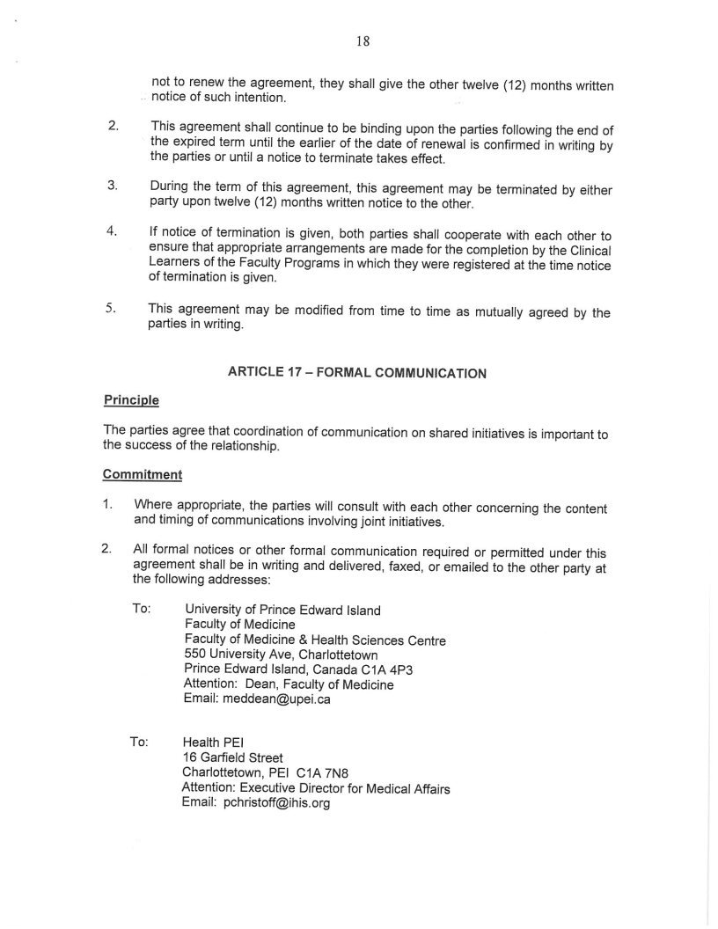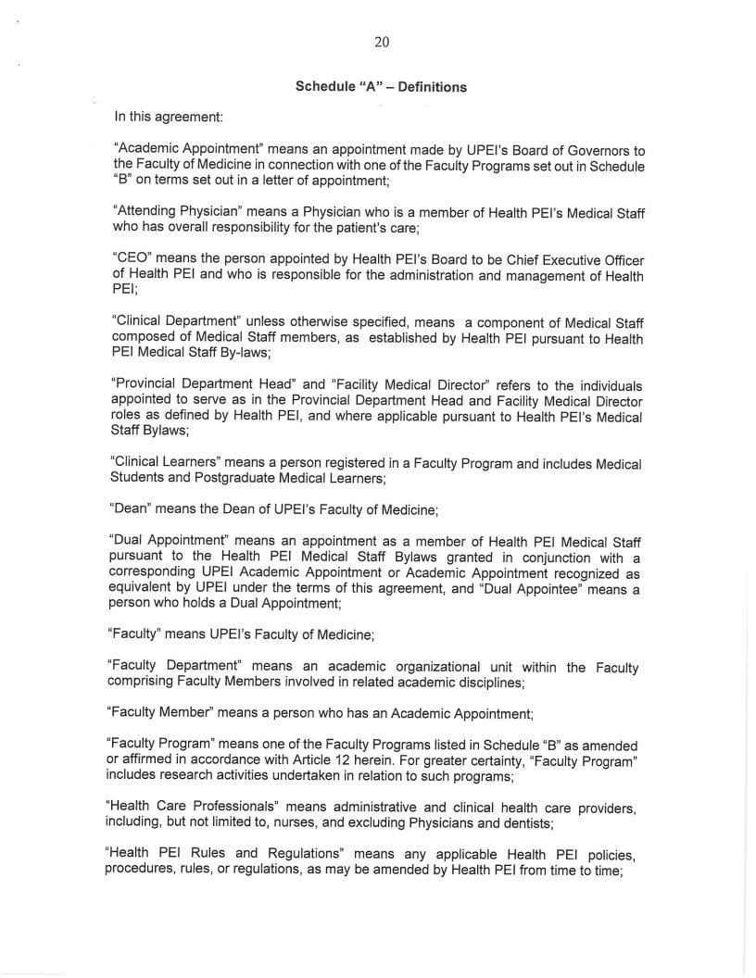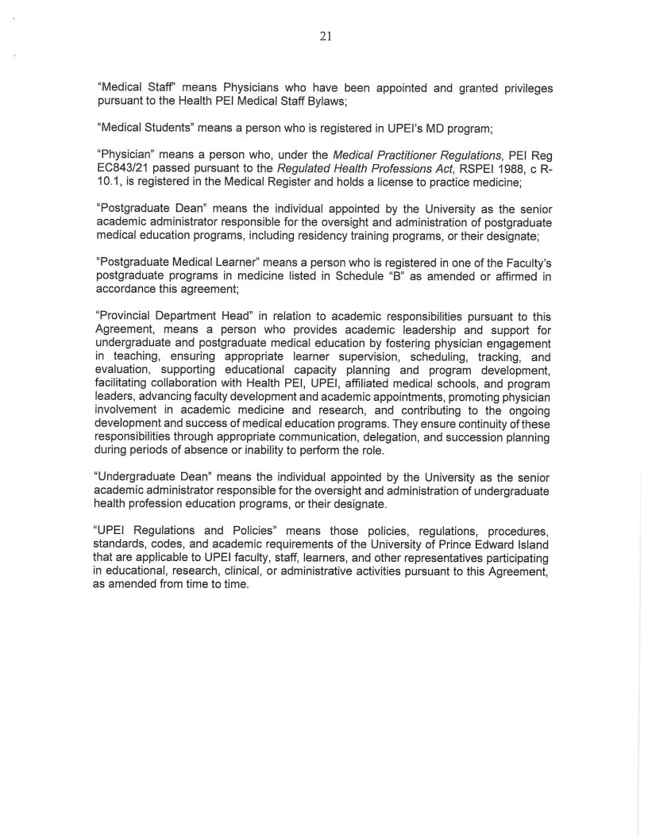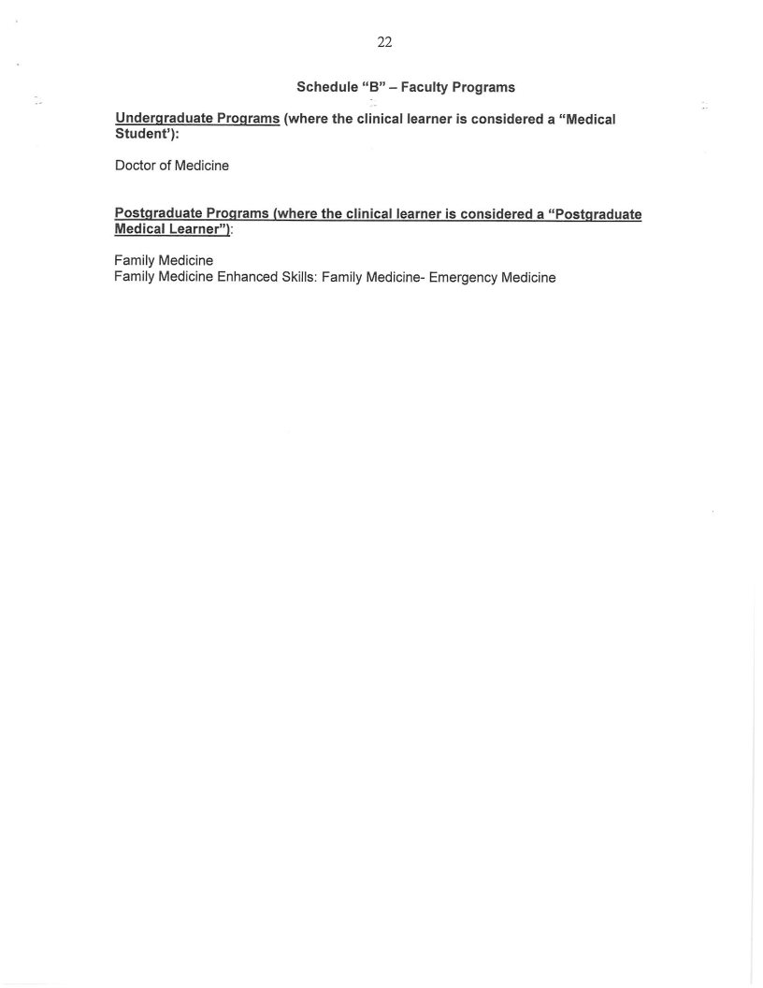
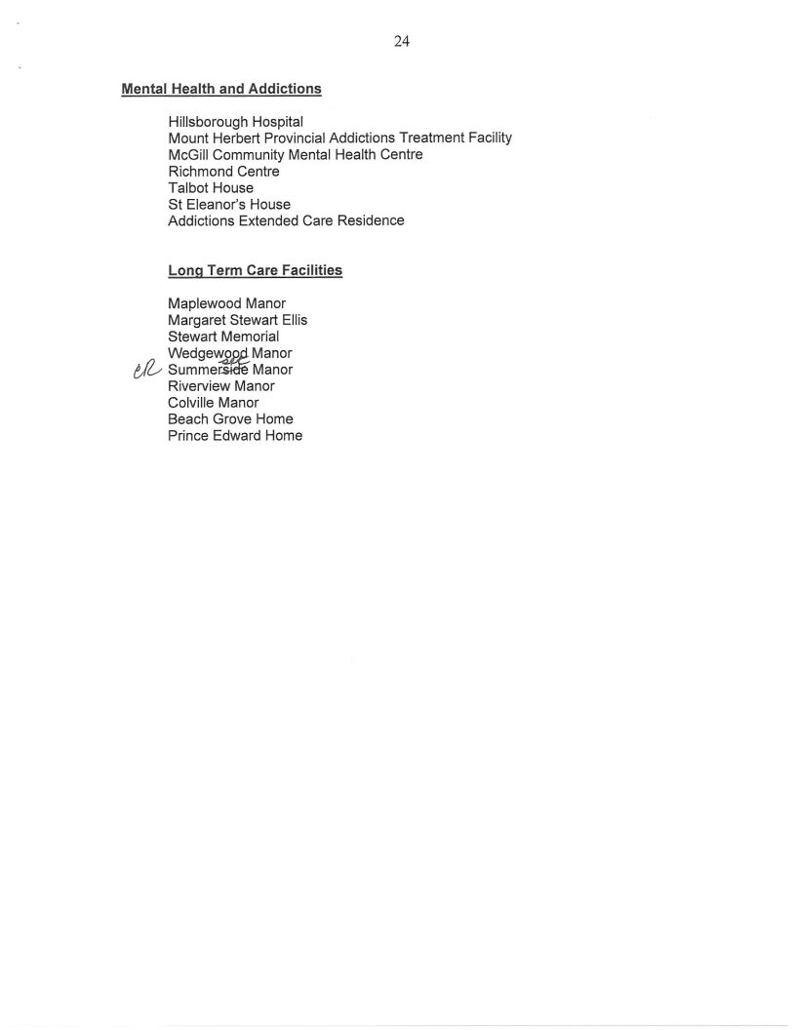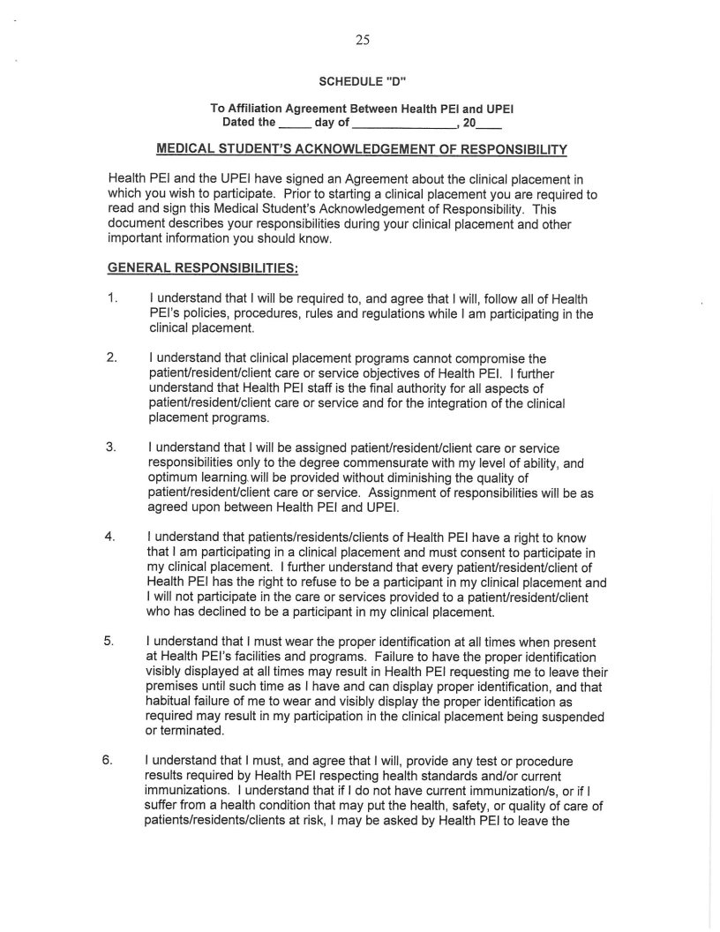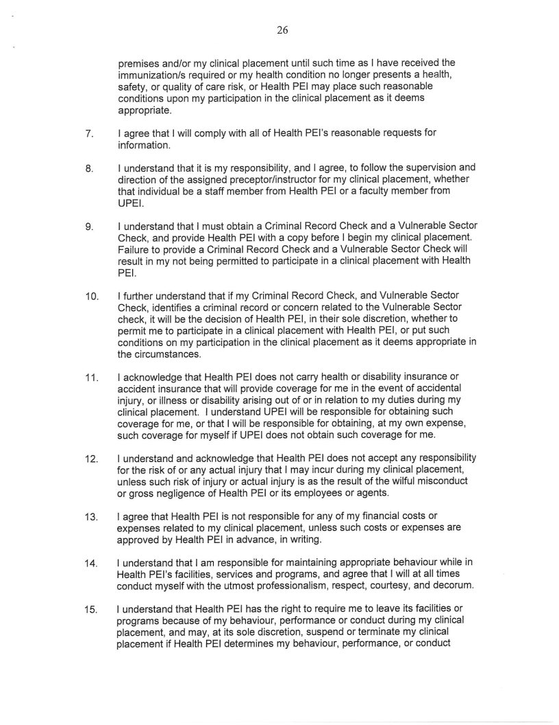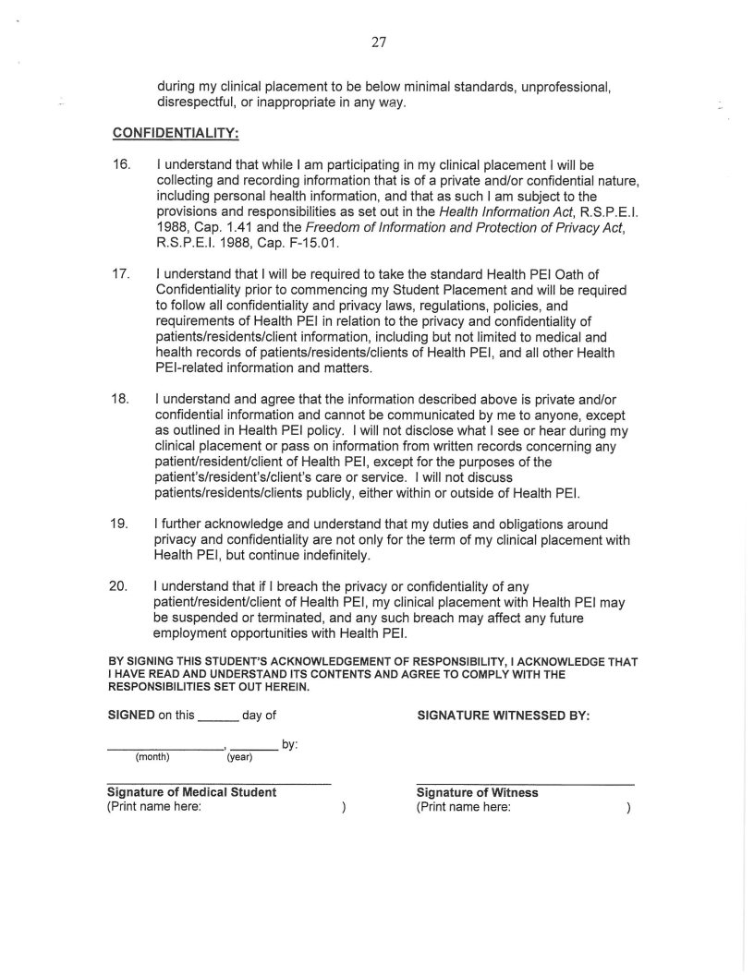

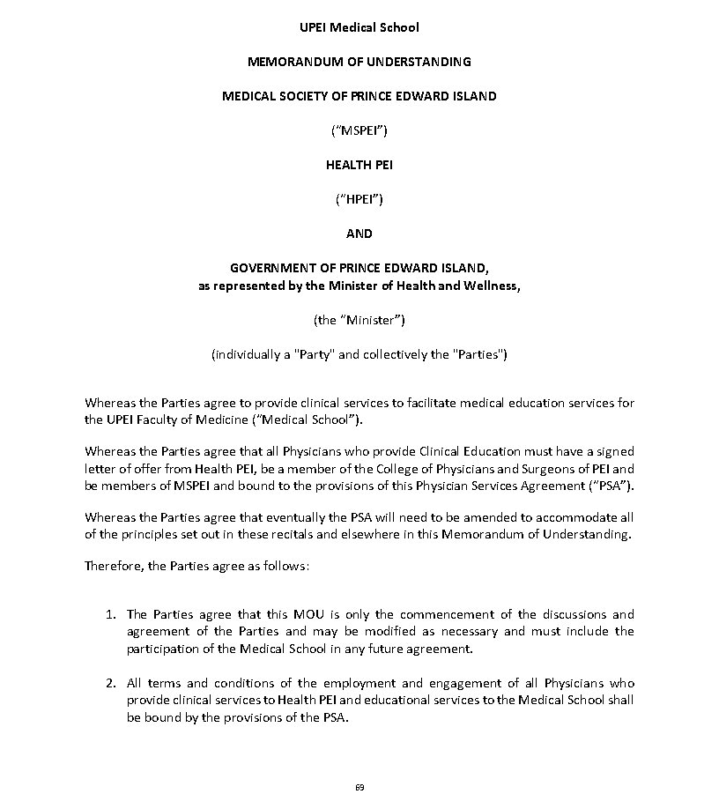
Appendix C: Physician Services Agreement between The Medical Society of PEI and the Government of PEI and Health PEI: UPEI Medical School Memorandum of Understanding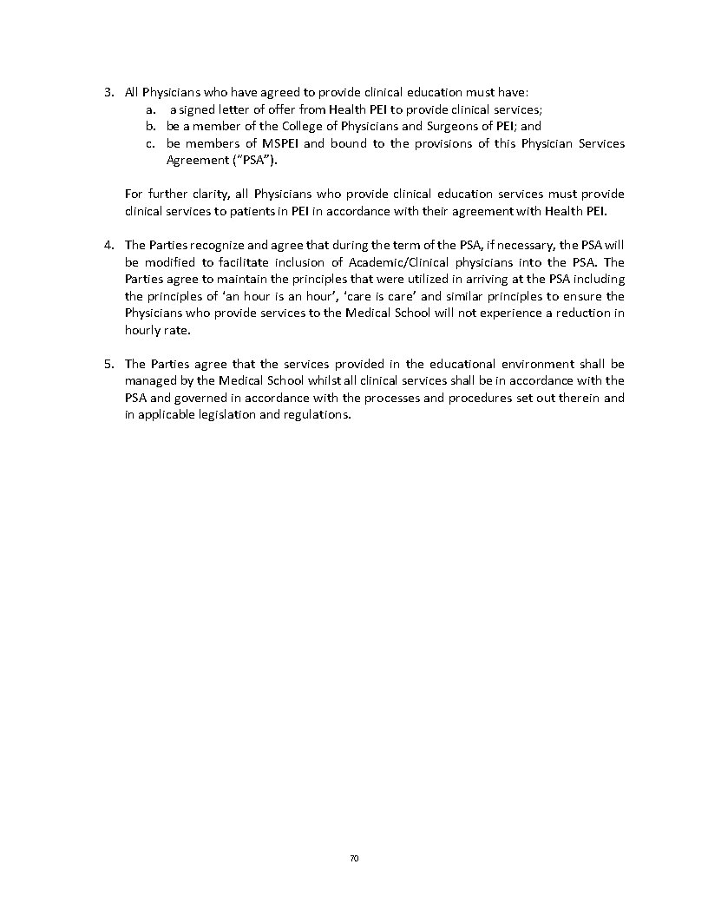

Appendix D: CACMS Standards 2 and 4 Questions
Standard 2
STANDARD 2: LEADERSHIP AND ADMINISTRATION
A medical school has a sufficient number of faculty members in leadership roles and of senior administrative staff with the skills, time, and administrative support necessary to achieve the goals of the medical education program and to ensure the functional integration of all programmatic components.

2.1 SENIOR LEADERSHIP, SENIOR ADMINISTRATIVE STAFF AND FACULTY APPOINTMENTS
The dean and those to whom the dean delegates authority (e.g., vice, associate, assistant deans), department heads, and senior administrative staff and faculty members of a medical school are appointed by, or on the authority of, the governing board of the university.

Requirement 2.1-1
The dean and those to whom the dean delegates authority (e.g., vice, associate, assistant deans), department heads, and senior administrative staff and faculty members of the medical school are appointed by, or on the authority of, the governing board of the university or by other individuals who have been given the authority to make these appointments.

- Provide evidence that the dean, vice, associate and assistant deans and department heads are appointed by, or on the authority of, the governing board of the university. This evidence could include a university policy or equivalent document and/or redacted letters of appointment. (Appendix 2.1-1 A)

- Provide evidence that faculty members, including part-time and clinical faculty members are appointed by or on the authority of, the governing board of the university. Label and highlight the appropriate sections. (Appendix 2.1-1 B)

2.2 DEAN’S QUALIFICATIONS
The dean of a medical school is qualified by education, training, and experience to provide effective leadership in medical education, scholarly activity, patient care, and other missions of the medical school.

Requirement 2.2-1
The dean of the medical school is qualified by education, training, and experience to provide effective leadership in medical education, scholarly activity, patient care, and other missions of the medical school.

- Provide a one-page summary of the dean’s experience and qualifications to provide leadership in each of the missions of the medical school for which the dean is responsible.

2.3 ACCESS AND AUTHORITY OF THE DEAN
The dean of a medical school has sufficient access to the university president or other university official charged with final responsibility for the medical education program and to other university officials in order to fulfill the dean’s responsibilities. The dean’s authority and responsibility for the medical education program are defined in clear terms.

Requirement 2.3-1
The dean of the medical school has sufficient access to the university president or other university official charged with final responsibility for the medical education program and to other university officials in order to fulfill the dean’s responsibilities.

- Provide an organizational chart illustrating the relationship of the medical school dean within the university administration that includes the deans of other schools and colleges and other relevant university officials. (Appendix 2.3-1 A) (also for Core Appendix)

- Describe and comment on the sufficiency of the dean’s access to the university president or other university official charged with final responsibility for the medical education program and to other university officials to fulfill decanal responsibilities.

Requirement 2.3-2
The dean’s authority and responsibility for the medical education program are defined in clear terms.

- Provide the dean’s official position description. (Appendix 2.3-2 A)

2.4 SUFFICIENCY OF ADMINISTRATIVE STAFF
A medical school has in place a sufficient number of associate or assistant deans, leaders of organizational units, and senior administrative staff who are able to commit the time necessary to accomplish the missions of the medical school.

Requirement 2.4-1
The medical school has in place a sufficient number of associate or assistant deans, leaders of organizational units, and senior administrative staff who are able to commit the time necessary to accomplish the missions of the medical school.

- Provide an organizational chart of the medical school that includes the deanery, leaders of organizational units and senior administrative staff. (Appendix 2.4-1 A) (also for Core Appendix)

- Describe how the medical school determines that it has in place enough associate or assistant deans, leaders of organizational units, and senior administrative staff who are able to commit the time necessary to accomplish the missions of the medical school.

- Table 2.4-1 C

Table 2.4-1 C |  | Deanery, Leaders of Organizational Units, and Senior Administrative Staff  Source: School-reported
Provide the requested information regarding members of the dean’s office (vice, associate deans, and similar positions; leaders of organizational units [excluding department chairs], and senior administrative staff) who have held the listed position within the past three academic years. For each interim/acting appointment, provide the date the previous incumbent left office. For positions that are currently vacant, enter “Vacant” in the column labeled “Name of position holder.” Add rows as needed.
Campus | Position title |  | Name of position holder | Appointment status  (identify with an X) |  | Date appointed | Date previous incumbent left the position
Campus |  |  | Name of position holder | Permanent | Interim/Acting | Date appointed

Table 2.4-1 D
Table 2.4-1 D | Department Chairs |  |  | Source: School-reported
Provide the requested information regarding department chairs who have held the listed position within the past three academic years. For each interim/acting appointment, provide the date the previous incumbent left office. For positions that are currently vacant, enter “Vacant” in the column labeled “Name of position holder.” Add rows as needed.
Campus |  | Position title | Name of position holder |  | Appointment status  (identify with an X) |  | Date appointed | Date previous incumbent left the position
 |  | Position title |  |  | Permanent | Interim/Acting | Date appointed | Date previous incumbent left the position

2.5 RESPONSIBILITY OF AND TO THE DEAN

NB: Element 2.5 Is not applicable to UPEI and has been deleted from the DCI for Preliminary Accreditation (AY – 2026-2027). Element 2.5 will appear in future versions of the DCI, but so long as UPEI only has once campus, UPEI will not be required to respond to Element 2.5

2.6 FUNCTIONAL INTEGRATION OF FACULTY MEMBERS

NB: Element 2.6 is not applicable to UPEI and has been deleted from the DCI for Preliminary Accreditation (AY – 2026-2027). Element 2.6 will appear in future versions of the DCI, but so long as UPEI only has once campus, UPEI will not be required to respond to Element 2.6.

Standard 4
STANDARD 4: FACULTY MEMBER PREPARATION, PRODUCTIVITY, PARTICIPATION, AND POLICIES
The faculty members of a medical school are qualified through their education, training, experience, and continuing professional development and provide the leadership and support necessary to attain the institution's educational, research, and service goals.

4.1 SUFFICIENCY OF FACULTY MEMBERS
A medical school has in place a cohort of faculty members with the qualifications and time required to deliver the medical curriculum and fulfill the other missions of the medical school.

Requirement 4.1-1
The medical school has in place a cohort of faculty members with the qualifications and time required to deliver the medical curriculum.

- Describe how the medical school determines and ensures that it has in place a cohort of faculty members with the qualifications and time required to deliver the medical curriculum. If protected time is a strategy used, include this in your description.

Requirement 4.1-2
The medical school has in place a cohort of faculty members with the qualifications and time required to fulfill the other missions of the medical school.

- Describe how the medical school determines and ensures that it has in place a cohort of faculty members with the qualifications and time required to fulfill the missions of the medical school other than curriculum delivery. If protected time is a strategy used, include this in your description.

4.2 SCHOLARLY PRODUCTIVITY
A medical school’s faculty members, as a whole, demonstrate a commitment to continuing scholarly productivity that is characteristic of an institution of higher learning.

Requirement 4.2-1
The medical school’s faculty members, as a whole, demonstrate a commitment to continuing scholarly productivity that is characteristic of an institution of higher learning.

- Describe the medical school’s expectations for faculty member scholarly productivity.

NB: Indicator B., including Core Appendix 4.2-1 B has been deleted from the DCI for Preliminary Accreditation (AY-2026-27)

4.3 FACULTY MEMBER APPOINTMENTS
A medical school has clear policies and procedures in place for faculty member appointments, renewal of appointment, promotion, granting of tenure, remediation, and dismissal that involve a faculty member, the appropriate department head(s), and the dean, and provides each faculty member with written information about the faculty member’s term of appointment, responsibilities, lines of communication, privileges and benefits, performance evaluation and remediation, terms of dismissal, and, if relevant, the policy on practice earnings.

Requirement 4.3-1
The medical school has clear policies and procedures in place that involve the faculty member, the appropriate department head(s) and the dean when dealing with a faculty member’s:
- appointment.
- renewal of appointment
- promotion
- granting of tenure
- remediation
- dismissal

- List each type of faculty member appointment and provide a brief narrative description outlining key features of each appointment type.

- For each type of faculty member appointment, provide the medical school or university policies (or equivalent documents) and procedures for appointment, renewal of appointment, promotion, granting of tenure, remediation, and dismissal. Highlight and label these documents for each type of faculty member appointment and for each item listed (i – vi). (Appendix 4.3-1 B)

Requirement 4.3-2
The medical school provides each faculty member with written information about the faculty member’s:
- term of appointment
- responsibilities
- lines of communication
- privileges and benefits
- performance evaluation and remediation
- terms of dismissal
- the policy on practice earnings (if relevant)

- For each type of faculty member appointment, provide templates that show how each of the items listed (i – vii) are communicated in writing to faculty members. Highlight and label these documents for each faculty member appointment type and item listed (i – vii). (Appendix 4.3-2 A)

4.4 FEEDBACK TO FACULTY MEMBERS
A medical school faculty member, consistent with the terms of the faculty member’s appointment, receives regular and timely feedback from departmental and/or other educational program or university leaders on academic performance, and, when applicable, progress toward promotion or tenure.

Requirement 4.4-1
A medical school faculty member, consistent with the terms of the faculty member’s appointment, receives regular and timely feedback from departmental and/or other educational program or university leaders on academic performance, and, when applicable, progress toward promotion or tenure.

- Describe how medical school faculty members, consistent with their terms of appointment, receive regular and timely feedback from departmental and/or other educational program or university leaders on their academic performance, and, when applicable, progress toward promotion or tenure.

NB: Table 4.4-1 B and Indicator C. have been deleted from the DCI for Preliminary Accreditation (AY-2026-27)

4.5 FACULTY PROFESSIONAL DEVELOPMENT
A medical school and/or the university provides opportunities for professional development in those areas needed to fulfill faculty members’ obligations to the medical education program and to enhance faculty member’s skills and leadership abilities.

Requirement 4.5-1
A medical school and/or the university provides opportunities for professional development in those areas needed to fulfill faculty members’ obligations to the medical education program and to enhance faculty member’s skills and leadership abilities.

- Describe how the medical school or the university provides opportunities for professional development to each faculty member to enhance the faculty member’s skills and leadership abilities. Include in the description how and by whom, these opportunities are developed, provided, and evaluated.

- Describe how all full- and part-time faculty members are informed about the availability of faculty development activities. Include in the description the steps taken to ensure that faculty development opportunities are accessible to all faculty members.

- Provide a list by campus, of the faculty development programs/activities offered during the most recent academic year to assist faculty members in developing their skills and leadership in areas of academic responsibility. Include information on the general topic, number of attendees, and where these programs were offered. (Appendix 4.5-1 C)

4.6 GOVERNANCE AND POLICY-MAKING PROCEDURES
The dean or a dean’s delegate and a committee, the majority of which are faculty members at a medical school, determine the governance and policy-making procedures of the medical education program.

Requirement 4.6-1
The dean or a dean’s delegate and a committee, the majority of which are faculty members at a medical school, determine the governance and policy-making procedures of the medical education program.

- Describe how the dean or a dean’s delegate and a committee, the majority of which are faculty members at a medical school, determine the governance and policy-making procedures of the medical education program.

